Colour has the power to transform spaces, influence mood, and create atmospheres. Understanding colour theory, and the psychological impact of different colours, can significantly enhance the effectiveness of a design. This article delves into the basics of colour theory, explaining what colour is and how it is formed, and how various colours can be strategically used to evoke specific emotions and responses in interior spaces.

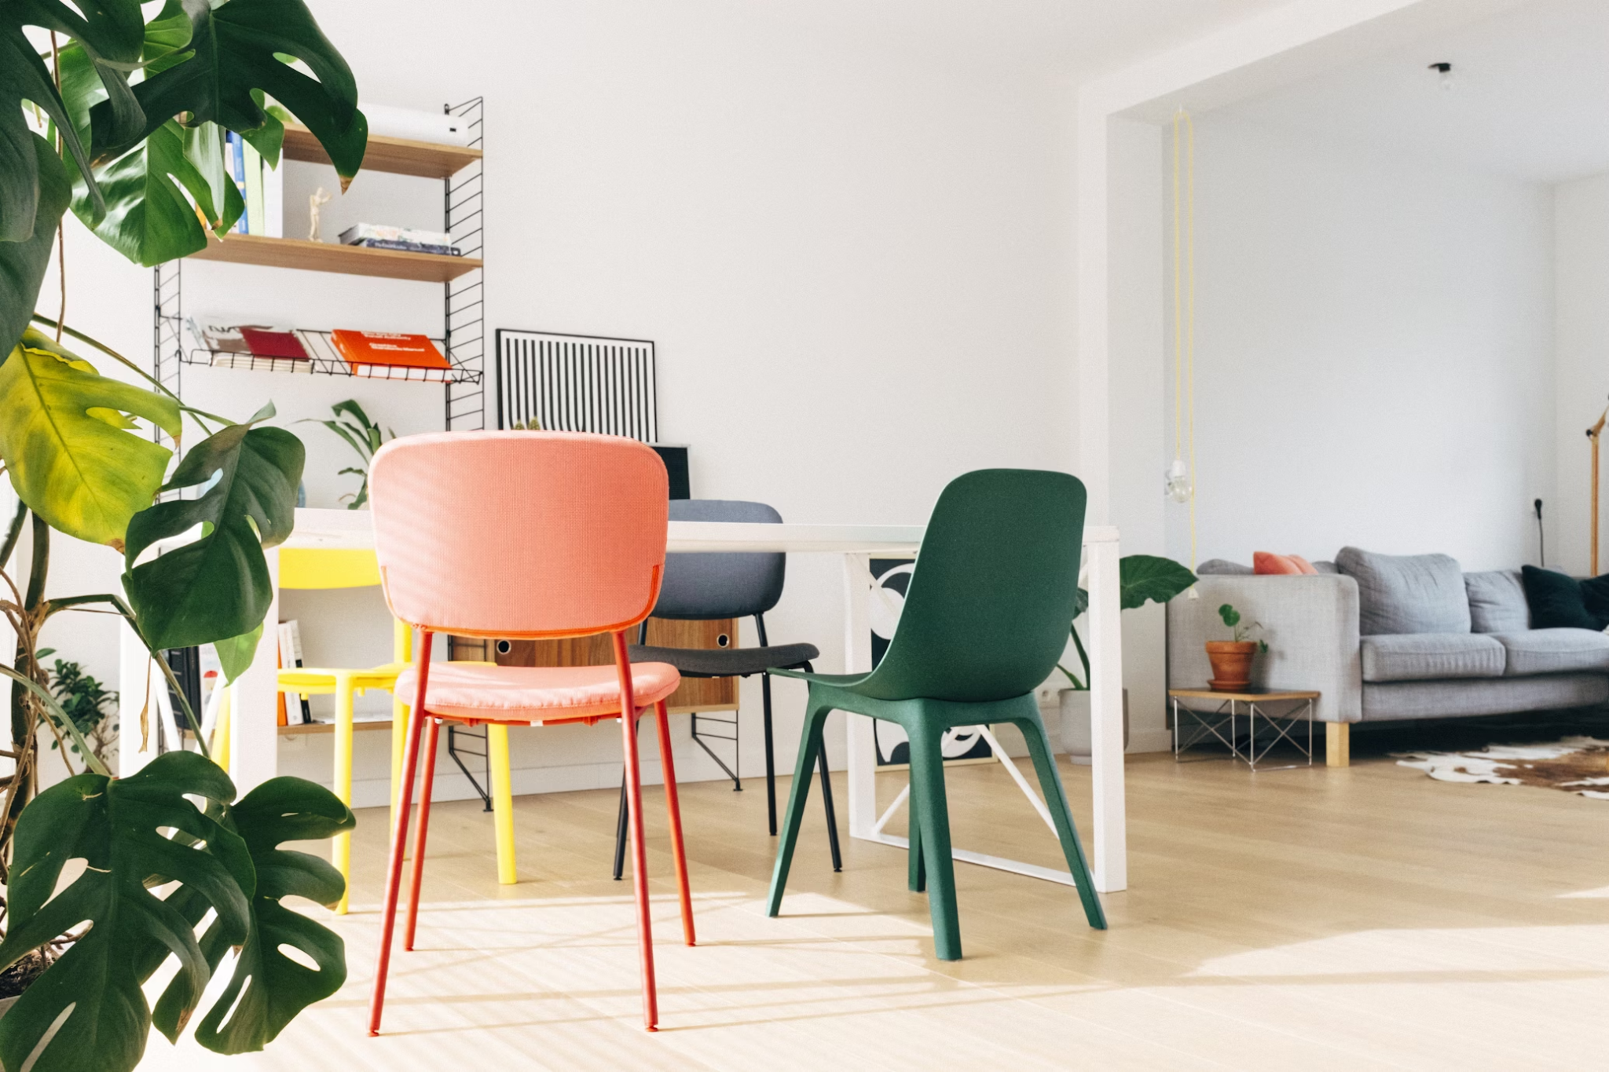

Fig. 1. Unsplash (2020), Green chair & white table

<https://unsplash.com/pt-br/fotografias/cadeira-verde-e-branca-ao-lado-da-mesa-branca-b2nNepkkWYs>

# What is Colour?

Colour is a fundamental aspect of human vision. It can be described as a visual perception, resulting from the way objects reflect or emit light wavelengths. It is described through colour categories with names such as red, blue, yellow, etc. The science of colour is intertwined with the physics of light, the chemistry of pigments, and the biology of human vision.

Colour is formed when light hits an object, the object absorbs certain wavelengths and reflects others. The colours we see are the wavelengths that are reflected. For example, a red apple appears red because it reflects red wavelengths of light while absorbing others.

Colour perception is a complex process involving the eyes and the brain. When light enters the eye, it hits the retina where photoreceptor cells called rods and cones respond to the light. Cones are responsible for colour vision and are sensitive to different parts of the spectrum (long, medium, and short wavelengths). The brain processes the signals from the cones and interprets them as colour.

Colour has four (4) main attributes, that we will be looking at: Hue, Tint, Tone and Shade.

# Basic Colour Theory

At its core, colour theory is a framework that guides the use of colour in design. It involves the science and art of using colour, based on the colour wheel, colour harmony, and the context in which colours are used. Colours exist in two main categories: chromatic and achromatic colours.

Firstly, let’s look at **chromatic colours**. These are all the colours we can see, such as royal blue, deep red, canary yellow etc. The base of all chromatic colours, which defines what our eye perceives (i.e. red, blue, yellow), is called the **Hue**.

**Achromatic colours**, which are also sometimes referred to as pure neutrals, are just three colours; white, grey and black. This is because these three colours do not have a specific hue, or base colour. However, these three colours can affect the status quo of all other colours and change their outcome in dramatic ways:

#### Hue= Pure Colour

Itrefers to the pure spectrum colours commonly referred to by the "colour names" (red, orange, yellow, blue, green, violet) that appear in the colour wheel. Hues are the foundation of colour, and are typically the base colour before any tint, tone, or shade is applied.

#### Tint= Hue + White

Thisis created when white is added to a pure hue. Tints are often associated with lighter, pastel-like colours that have a softer appearance. E.g. Pink is a Tint of Red, ie Red + White.

#### Shade= Hue + Black

It is created when black is added to a pure hue, darkening the colour. Shades are deeper and more intense, often associated with a more dramatic and moody ambiance.

#### Tone= Hue + Grey

Tone is created when grey (a mixture of black and white), is added to a hue. Adding grey to a colour reduces its intensity, and makes it more subdued and “earthy”. E.g. Dusty Rose is a Tone of Red, i.e. Red + Grey.

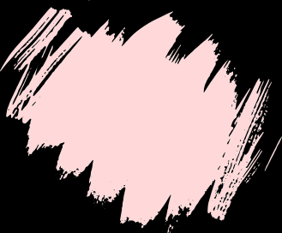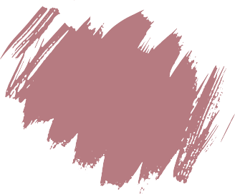

Fig. 2. From left to right: Pure Red, Tint of Red (Red + White), Tone of Red (Red + Grey), and Shade of Red (Red + Black)

Incorporating an understanding of hue, tint, tone, and shade into your interior design practice allows for greater control over the ambiance and aesthetic of a space.

# The Colour Wheel

The colour wheel is a tool that provides a visual representation of colours, arranged according to their chromatic relationships. It serves as the basis for understanding how colours interact with one another, how to create harmonious colour schemes, and how to effectively use colour in design. The colour wheel provides information such as, which colours are primary, secondary and tertiary. It supports the different colour schemes you can create, and explains the basic colour theory concepts that we discussed above.

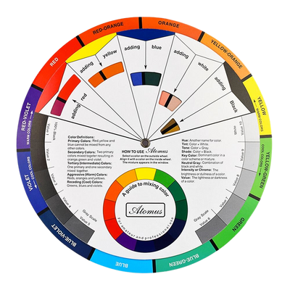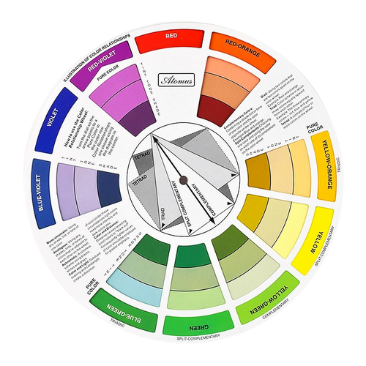

Fig. 3. Amazon.com (n.d.), Front and back view of a colour wheel

**Primary Colours:** Red, blue, and yellow are the foundation colours that cannot be made by mixing other colours.

**Secondary Colours**: Green, orange, and purple, created by mixing primary colours.

**Tertiary Colours:** Colours formed by mixing a primary colour with a secondary colour (e.g. red-orange, blue-green).



Fig. 4. From left to right: Primary, Secondary, Tertiary Colours